**InsightStream: Navigate the News Landscape**

**Project Design Phase-II**

**Data Flow Diagram & User Stories**

|  |  |
| --- | --- |
| Date | 11/03/2025 |
| Team ID | ID-149960 |
| Project Name | InsightStream: Navigate the News Landscape |
| Maximum Marks | 4 Marks |

**Data Flow Diagrams:**

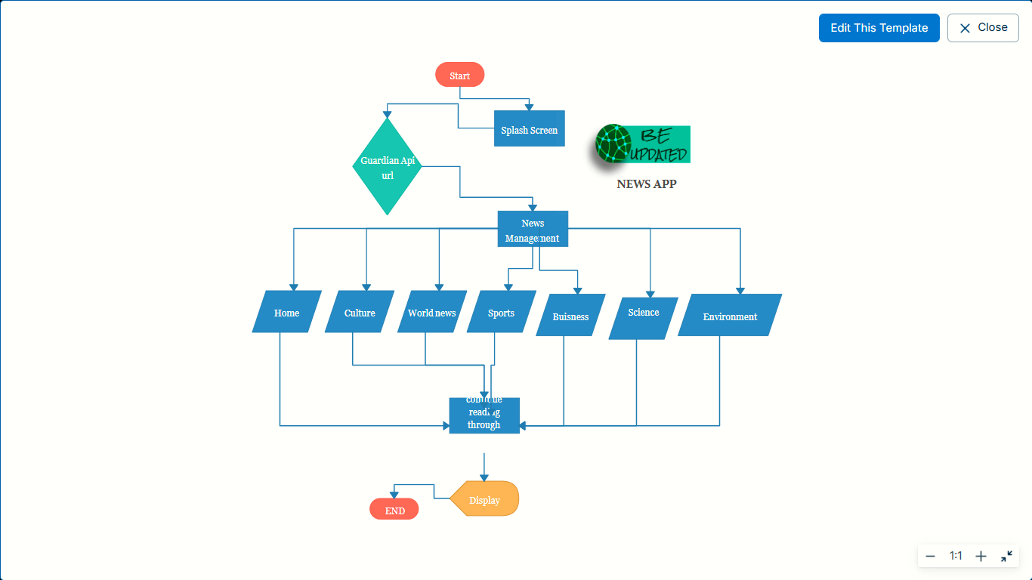

**User Stories**

**User Story Table – News reading App**

|  |  |  |  |  |  |  |
| --- | --- | --- | --- | --- | --- | --- |
| **User Type** | **Functional Requirement (Epic)** | **User Story Number** | **User Story / Task** | **Acceptance Criteria** | **Priority** | **Release** |
| **Time-Conscious Reader** | News categories | USN-1 | As a user, I can read the news based on the category. | The user should be able to see real-time trending news from various sources. | High | Sprint-1 |
| **Trend-Focused Reader** | Default news | USN-2 | As a user, I can see the trendy news at the default page | The user should be able to opt-in for daily or weekly email subscriptions. | High | Sprint-2 |
| **Mobile-First User** | Mobile-Friendly Experience | USN-4 | As a user, I want a fast and responsive news experience on mobile. | The app should be optimized for mobile devices with smooth scrolling. | High | Sprint-4 |
| **In-Depth Reader** | News Browsing | USN-3 | As a user, I can read the complete article with courtesy. | The user should be able to opt-in for daily or weekly email subscriptions. | High | Sprint-3 |

**Time-Conscious Reader** – This type of user wants to stay informed with relevant news quickly and efficiently. They seek a structured way to access news based on categories such as politics, business, sports, and technology. The app should display real-time trending news from various sources, allowing users to stay up to date without unnecessary distractions.

**Trend-Focused Reader** – These users prefer staying ahead of current events and viral topics. They want their default news feed to be filled with the latest, most talked-about stories without needing to search for them manually. Additionally, they should have the option to receive daily or weekly email subscriptions to get curated updates right in their inbox.

**Mobile-First User** – With most users relying on their smartphones for news consumption, it is crucial to provide a fast, responsive, and mobile-optimized experience. This user expects smooth scrolling, quick loading times, and an interface that adapts well to different screen sizes. Any lag or unresponsive behavior can drive them away from the app.

**In-Depth Reader** – This user prefers to read complete articles without interruptions. They value long-form journalism and detailed reports rather than just summaries or snippets.The app should ensure a seamless reading experience with properly formatted articles, easy scrolling, and an ad-free or minimally intrusive interface to maintain reader engagement.